

Bilkent University

**CS 353 Project Proposal**

Aziz Osman Kozhan 21401136

Talha Şeker 21302144

Serhat Aras

TABLE OF CONTENTS

|  |  |
| --- | --- |
| **Project Description** | 2 |
| Requiring a Database System | 2 |
| **Requirements** | 3 |
| Functional Requirements | 3 |
| Hosts | 3 |
| Guests | 3 |
| System Requirements | 4 |
| Nonfunctional Requirements | 4 |
| User Friendly Interface | 4 |
| Easy Maintenance | 4 |
| Quick Response Time | 4 |
| **Limitations** | 5 |
| **Entity Relationship Diagram** | 6 |
| **Webpage** | 7 |
| **Conclusion** | 7 |

1. Project Description

In our project we aim to create an online hiring management system similar to that of Armut.com which we will call PlaceHolder. The system that we propose will bring together customers(users) who want to find a professional to do a certain work and professionals who need a job and have offer about this certain task. The system will do this by storing data about users, professionals, and works to be done and user reviews.

Customers will be able to log in to the system and create a well-defined work. For example, customer can state cost range of the work and any needed limitations. Then, the system is going to channel this job to relevant professionals based on professionals’ user reviews and their career background. Next, professionals who are interested in the job prepare an offering inside the system and this offering is sent to the customer who prepared the job by the system. The offering can include cost, quality, time cost, and resource allocation for this work. The customer compares these offerings and choose one of them. After choosing the professional, customer can directly communicate with the professional through the system. After work is done, customer and professional will be able to rate each others’ manners.

1.1. Requiring a Database System

This project aims to provide a fast way of connection between customers and professionals. Since large amount of data about customers, offerings, professionals jobs and any other information with those mediums have to be stored and maintained, a database system fits the project’s purpose well. Moreover, as the project utilizes user input such as jobs, offerings, reviews this data needs to be easily changeable. With the help of a database system, storing and maintaining information will be handled quickly and easily, and the changes that need to be done to the system will be handled efficiently.

2

1. Requirements

2.1. Functional Requirements

There are two main types of actors, or users, that will use the proposed system. PlaceHolder will allow the users to be only a customer or a professional. Each individual will be able to do the functionalities listed below.

2.1.1. Customers

* Customers will be able to register for an account in the system. The customer will be able to log into the system with this account.
* Customers will be able to add or remove a job.
* Customers will be able to configure specifications about the job.
* Customers will be able to revise and update any job configurations created before.
* Customers will be able to see and compare offerings which are sent from relevant professionals.
* Customers will be able to choose the best offering for themselves and the customer will be able to communicate with selected professional through the system.
* After work is done, customers will be able to make a review of the professional and the job is done and they can give feedback through the system.

2.1.2. Professionals

* Professionals will be able to register for an account in the system. The professional will be able to log into the system with this account.
* Professionals will be able to update their background information about education, career etc.
* Professionals will be able to see relevant jobs which are created by customers.
* Professionals will be able to view the reviews about themselves and other professionals.
* Professionals will be able to prepare offerings for jobs that they are interested in.
* After work is done, professionals will be able to make a review of the customer and the job is done and they can give feedback through the system.

3

2.1.3. Recommended System Requirements

* System should have a compatible web browser.
* System should have minimum 256 MB of RAM and Intel core 2 duo 1.6 GHz CPU or higher.

2.2. Nonfunctional Requirements

2.2.1. User Friendly Interface

The proposed system should be user-friendly and easy to use. The customers should be able to create for a job easily, with as minimum buttons and complications as possible. The interface should be simplistic, without complexity and clear from any destruction because it is a business website.

2.2.2. Easy Maintenance and Reliability

The database systems that all the necessary information are to be kept in should be easy to maintain. The database should be scalable for the future improvements. Database system should reliable to avoid loss of data and data leakage.

2.2.3. Response Time

Since the proposed system operates on the interactions of the users, there will be a lot of changes in short time periods, and the databases should update accordingly so as not to interfere with the processes of the other users. Furthermore, since there will be a big amount of data that is utilized in the webpage, the waiting times should be kept to a minimum, to prevent long response time between processes.

4

1. System Limitations
   * Customers and professionals cannot rank and review each other until work is done.
   * A job can be added only after configurating specifications about the job.
   * Edit job can be active only for a certain period of time. In case, there has not any offering for the along this period, this job will be cancelled automatically.
   * A professional can get at most three jobs at the same time.
   * Customer and professional must have at least 3.5 rating point to be able create job or giving offering for a job.

4. Technical Limitations

**Variety of Dat**a: The type of the database we use for our design constraints us to be careful

about the structure of the data we use. The data stored must be structured.

**Velocity of Data**: The velocity of the data we process is also constrained to the functionality

of the database. In order to overcome this limitation we will need to provide extra

functionality using Information Retrieval techniques.

**Volume**: This technical limitation also refers to the scalability potential of the system. Our

ability to support a large amount of data is limited to the constraints of MySql database.

5. Recommended System Requirements

* System should have:

Windows XP or higher version.

Linux distro version 12.0 or higher.

MacOS 10.8 or higher.

Android 4.4.2 or higher.

iOS 8 or higher.

* System should have a compatible web browser.
* System should have minimum 256 MB of RAM and Intel core 2 duo 1.6 GHz CPU or higher.

5

1. Entity Relationship Diagram

6

1. Webpage
2. Conclusion

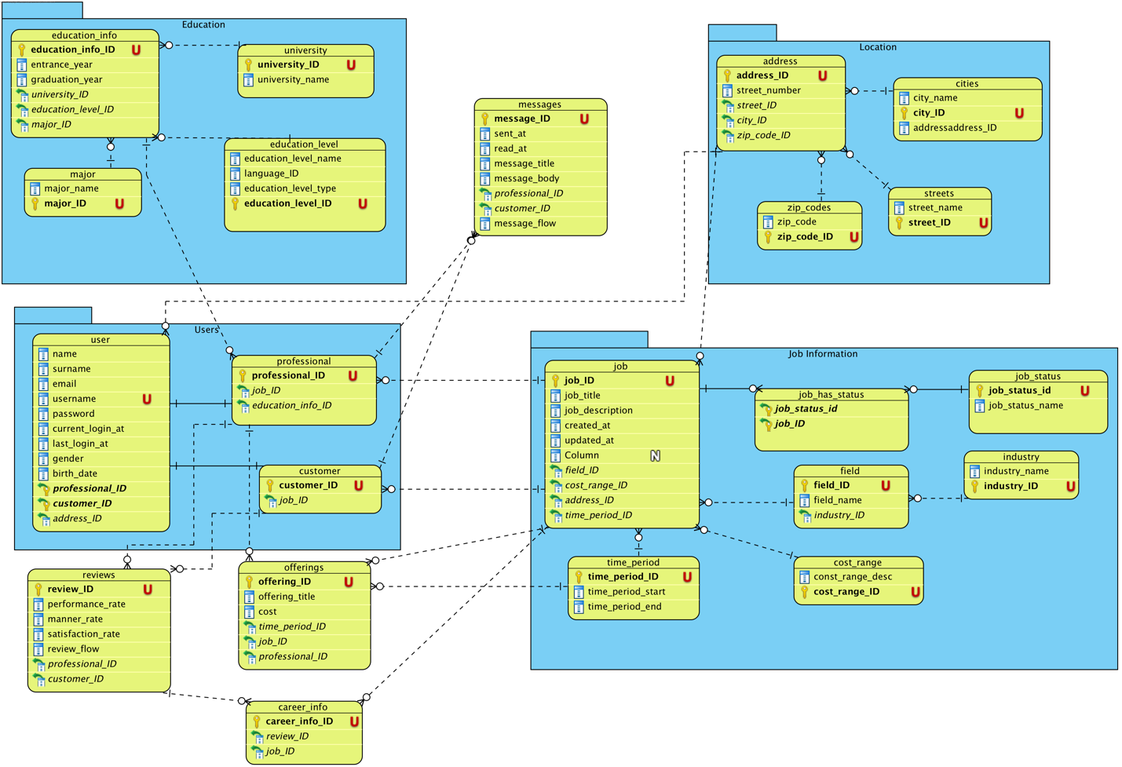7